1. Create a file like nano file1.txt

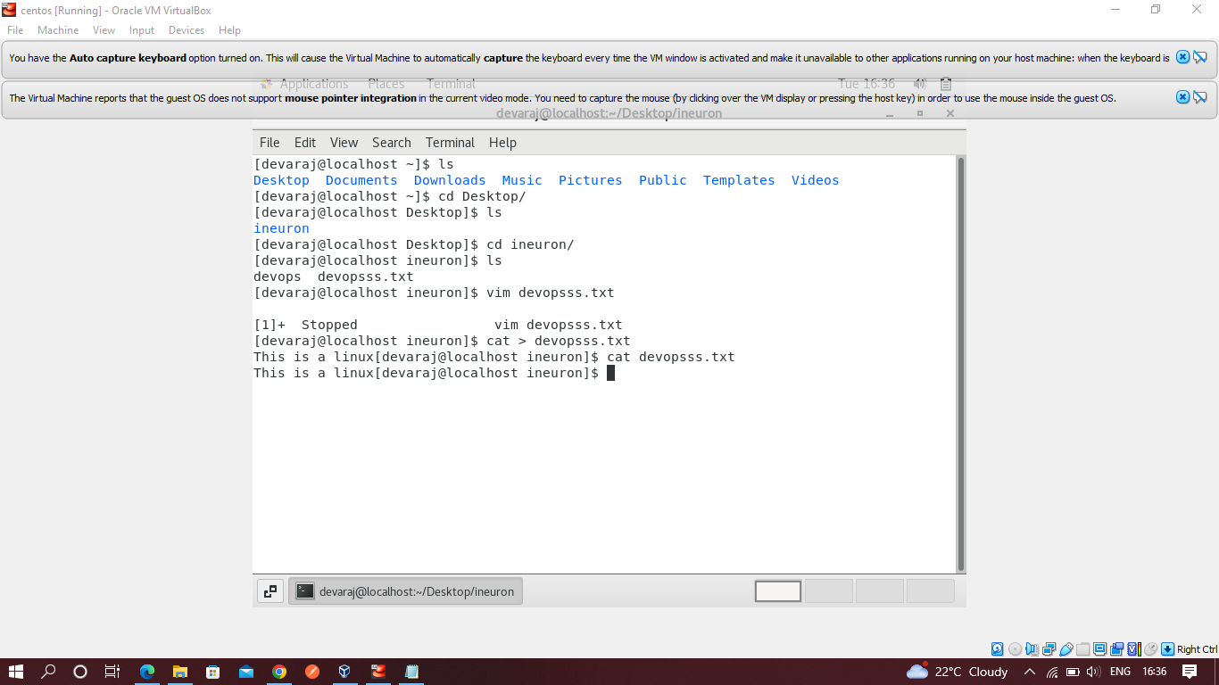

1. Now we will copy date from file1 to new file2

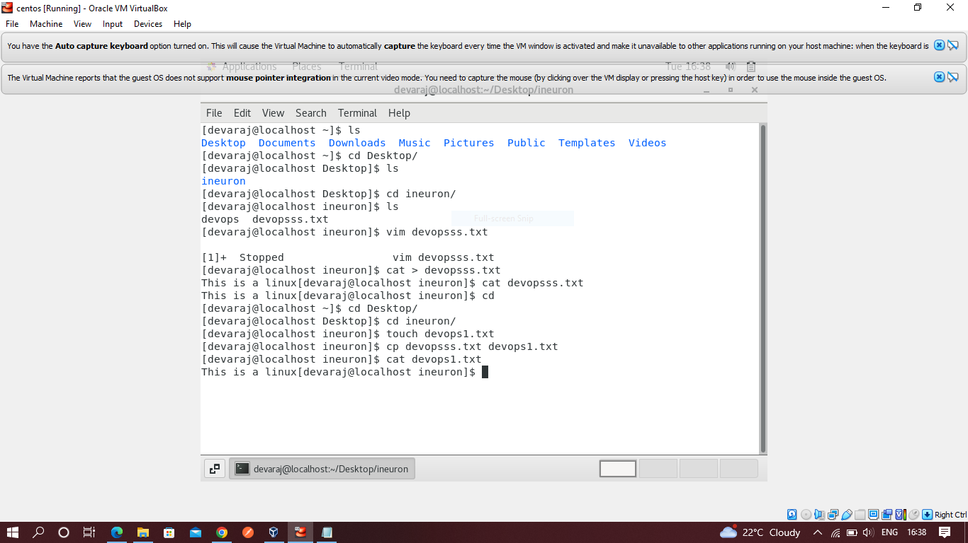

1. Now we will move the file2.txt to new folder /home

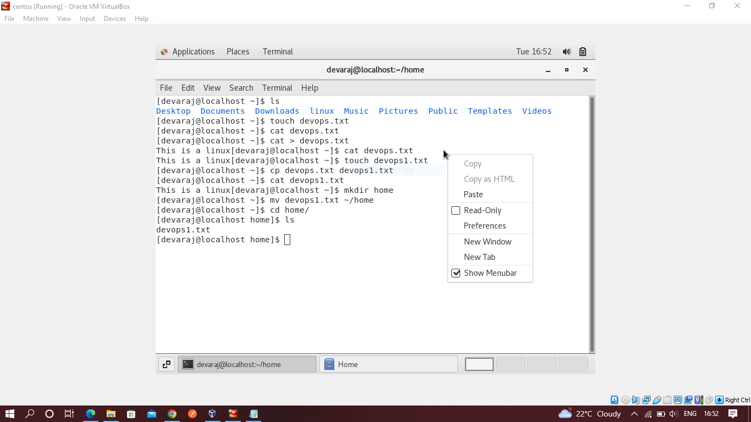

1. Then we create a new file3.txt and file4.txt in home directory and add content in it.

